POIESIS
by
SUSAN LEE HARMON
(Under the Direction of Patricia Walker)
ABSTRACT
This thesis is inspired by poetry, fiction, non fiction, and music. It examines mark-making techniques in my art and the inspirational writings behind them. Because of their importance to my work an historical examination of the role of mark-making in art will be undertaken beginning with Paleolithic cave art, and continuing with petroglyphs and pictographs. Three contemporary visual artists, including Jean-Michel Basquiat, Cy Twombly, and Susan Rothenberg whose own personal marks influence my mark-making are discussed. My artistic process is explained through reference to the materials and rituals used to create the thesis body of art. This thesis researches the meaning behind artistic marks, how marks are made in my art and in the art of other artists.

INDEX WORDS: Art, Poetry, Marks, Color, Pictographs, Paleolithic, Mark-making, Artwork, Expressionistic Art.

Author: Harmon, Susan Lee.

Title: Poiesis [electronic resource] /by Susan Lee Harmon.

Publisher: 2007

Description: xx p.: ill.

Notes: Thesis (M.F.A.)--Georgia Southern University, 2007. Includes
bibliographical references (p.79). Author's abstract: This thesis is inspired
by poetry, fiction, non fiction, and music. It examines mark-making
techniques in my art and the inspirational writings behind them. Because
of their importance to my work an historical examination of the role of
mark-making in art will be undertaken beginning with Paleolithic cave
art, and continuing with petroglyphs and pictographs. Three contemporary
visual artists, including Jean-Michel Basquiat, Cy Twombly, and Susan
Rothenberg, whose own personal marks influence my mark-making are
discussed. My artistic process is explained through reference to the
materials and rituals used to create the thesis body of art. This thesis
researches the meaning behind artistic marks, how marks are made in my
art and in the art of other artists.

System requirements: PC, World Wide Web browser and PDF reader.
Available electronically via Internet.

Subject(s): Georgia Southern University-- Dissertations.
Poetry and art-- Exhibitions.

Linked Resource: marks, painting, drawing, pictographs, paleolithic, mark-making,
artwork, expressionistic art.......

Location: Available On line

Call Number:

POIESIS

by

SUSAN LEE HARMON

Bachelor of Fine Arts, The University of Illinois, Champaign-Urbana, Illinois 1978

Bachelor of Fine Arts, The School of The Art Institute of Chicago, Chicago, Illinois, 1980

A thesis submitted to the Graduate Faculty of Georgia Southern University in partial
fulfillment of the requirements for the Degree

MASTER OF FINE ART

Statesboro, Georgia
2007

@ 2007
Susan Lee Harmon
All Rights Reserved

POIESIS
by
SUSAN LEE HARMON

Major Professor: Patricia Walker
Committee: Dr. Bruce Little
Dr. Onyile Onyile

Electronic Version Approved:
November 2007

DEDICATION

I dedicate this thesis in memory of my loving father and mother. I also dedicate this thesis to my supportive husband, David, and children, James, Stephen, Daniel and Michael.

ACKNOWLEDGEMENTS

I would like to express my sincere appreciation to Patricia Walker for her patience and immense assistance in the preparation of this thesis paper. Thanks to Dr. Bruce Little and Dr. Onyile Onyile for their valuable input in writing this thesis and inspiring studio critiques.

TABLE OF CONTENTS

Page

ACKNOWLEDGEMENTS.....................................................................................7
LIST OF FIGURES.................................................................................................9
INTRODUCTION.................................................................................................11
CHAPTER:
1. INSPIRATIONAL WRITINGS........................................................................13
2. HISTORICAL AND ARTISTIC INFLUENCES.............................................31
3. ARTISTIC PROCESS AND TECHNIQUES................................................. 62
CONCLUSION......................................................................................................72
ENDNOTES...........................................................................................................75
BIBLIOGRAPHY..................................................................................................76

LIST OF FIGURES

Page

Figure 1: Coda: The Final Phase of a Symphony,
80”x55”, mixed/paper, 2006 19
Figure 2: Words Floating and Falling,
80”x55”, mixed/paper, 2006 22
Figure 3: Dreams Spilling Over,
80”x55”, mixed/paper, 2006 25
Figure 4: Nocturnal Silence #1,
22”x30”, pastel/paper, 2006 28
Figure 5: Freedom is Gone#1,
22”x30”, pastel/paper, 2006 31
Figure 6: Small Engraved and Painted Horses,
Lascaux Cave, Nave, Dordogne, France 35
Figure 7: Paleolithic Sanctuary#1,
80”x30”, mixed/brown paper, 2006 37
Figure 8: Large Panel of Red Dots, Chauvet Cave,
Entrance to the Alcove of Yellow Horses,
Rhone Valley, France 39
Figure 9: Cave Marks#1, 18”x24”, mixed/paper, 2006 41
Figure 10: Death Rattle, 22'x30”,
Chalk pastel/blue paper, 2006 46
Figure 11: Two Souls, 10”x10”,
mixed/ masonite board, 2007 48
Figure 12: In This Case, Jean- Michel Basquiat,
77”x74”, acrylic and oil paintstick, 1983 51
Figure 13: Dead Silence, 22”x30”, mixed/canvas, 2007 53
Figure 14: Untitled, Cy Twombly, 27”x39”,
oil pastel, industrial paint/paper, 1970 56
Figure 15: Untitled#1, 30”x40”, mixed/canvas, 2007 58
Figure 16: The Monk, Susan Rothenberg,
5'9”x 8'9”, oil/canvas, 1983 61
Figure 17: Finlandia#1, 6'x4', oil, acrylic, pastel/canvas, 2007 63
Figure 18: Outsider Art, Mikey Welsh,
mixed/masonite board, 2002 69
Figure 19: Lives Stolen, 22”x30”, mixed/canvas, 2007 71
Figure 20: Ladies Lost, 18”x20”, mixed/canvas, 2007 73

INTRODUCTION

“Every poem begins with a lump in your throat”
Robert Frost

Stories inspire me to paint. Poetry and music fuel the passion for me to create.
The purpose of this thesis is to provide a critical, historical and theoretical analysis of the art work presented in my Master of fine Arts thesis exhibition which use mark-making to express my emotional responses to these inspirational writings. Because of their importance to my work an examination of the role of mark-making in art will be undertaken beginning with the first marks of Paleolithic man and continuing with Native American petroglyphs and pictographs. This thesis examines three contemporary visual artists; Jean-Michel Basquiat, Susan Rothenberg, and Cy Twombly who have developed their own unique marks in their art. The content of my work focuses on people whose lives have been stolen and in retrospect may have been triggered by my father's sudden and horrible death. Although I cannot ignore the physical and emotional horrors which befell these people, I choose to dwell on the hope held by the survivors and their unforgettable journey. In Chapter I specific examples of the writings that inspired my images are presented. The importance of these writings as the motivation behind my images places them in Chapter One. Chapter II discusses the historical influences on my art which includes Cave art, Outsider artists, and 20th century artists. The marks of early human precursors to writing have direct influence on my work in the form of symbols and shapes which help me to develop my own visual language.
Chapter III presents my actual art works and the process I use to make them. Of particular interest is a description of the rituals I use in the act of painting. Such rituals are almost sacred and sometimes seem more important than the final painting. In creating this body of art I have experienced a powerful emotional and intellectual journey and hope that these strong emotions are translated in my images. The death of a loved one is a universal experience and the resulting emotions affect all of us. My father's death is the beginning of my interest in making marks about tragic losses. This led me on this path of discovering the strength people seem to find to survive even the most threatening and dangerous experiences. While I cannot erase the physical and emotional scars that accompany such loss, through my art I hope to make them visible for the world to see.

CHAPTER 1

INSPIRATIONAL WRITINGS

A poem can change your life.
In poems, we discover the words
and images to understand and
interpret the world. Whether writing
birth songs or eulogies, love vows or
political anthems, lyric outbursts or
vast narratives, great poets throughout
the ages transform ordinary experience,
thought, and emotion into something
memorable. Dominique Raccah

This chapter begins with an autobiographical statement which may have triggered my interest in writings about death or dying. Several drawings and their inspirational words are presented. A discussion of the formal elements of each drawing with an emphasis on expressive mark-making is given. These art works are not illustrations nor instructive. They are meant to express my deepest and most private feelings about these poems, songs or stories. These artworks represent the use of mark-making as an expressive tool. I have scratched, torn, and clawed these canvases with my fingernails to express my emotions visually. I have smeared, pushed and built up paint with my hands in order to translate my inner most feelings upon my surfaces.
Paul Cezanne once said, “A work of art which did not begin in emotion is not art”. Emotionally-charged subject matter is at the core of my work, without it, I would have no story to inspire me to paint. I tap into these extreme feelings by preparing my subconscious with research, sketches and the writing of important words on the walls where the blank canvases will be placed before I begin to create the image. Most of the inspirational writings that influence my work are about death. Because of my own father's sudden and horrible death and the awful circumstances surrounding it I relate to these stories. But I also admire these people for their courage to survive these nightmares. The stories I use are about people who suffer extreme physical and mental pain. These writings have a connecting theme of close relationships between people: father and son in the book The Road by Cormac McCarthy, six friends in Left to Tell by Immacule Ilibagiza, and two sisters in Rena's Promise by Heather Dune Macadam. These stories are about people who hope to survive, who’s strong and yet shaken religious beliefs prevail in the end.
What is it in these poems/songs/books that stimulate me to make this body of art? It is not the rhythm of the words nor their inflections or intonations. More likely it is a phrase, two or three words put together in a unique way which creates visual imagery in my mind. Moods are created through poetry, imagination is stimulated and wisdom may be discovered. Poetry has many hidden meanings that may reveal themselves slowly as each layer is analyzed and pondered. Similarly, the many layers of paint in my art are built up slowly to reveal hidden meaning when decoded. The artworks depicted in this chapter share common physical similarities. They all begin with the drawing of solid thick black lines to establish the composition. The black lines still remain visible after the works are completed. While these lines vary in length, size, shape and thickness they do represent the wires and bars which kept the prisoners from freedom. The lines symbolize the religious beliefs of most of the subjects and how their belief in god falters and comes back again through their struggle to survive. The black lines are the connecting winding road these people travel, although very dangerous at times, a road which in the end becomes safe. The handling of paint in a very thick built up manner to express emotionality and the use of the white space around each image is consistent in all of these works. However the greatest similarities are in the mark-making. Some marks are very carefully laid down while others are put down in a quick and intense manner. Scribbles and flowing marks are constant in all. These art works stress marks, some subtle and delicate while others are bold and repetitive.
Coda, The Final Phase of a Symphony (figure.1, pg. 19), is the first of the drawings I examine because it marks the beginning of my search for peace in my father's dying. This drawing is the only one not inspired by the words rather the drawing came first, and then I found the passage which relates to it. It was not until after I made the drawing and then read a passage from act one of Hamlet by William Shakespeare, did I realize what this drawing was about. After my father passed away I spent many months drawing and painting a series entitled About Dying. The final picture from this series needed to have a positive tone to remember my father in a good way. Coda is the final drawing about my father's death and my acceptance of it.
“Do not for ever, with thy veiled lids. Seek, for thy noble father in the dust. Tho know'st tis common; all that lives must die,
Passing through nature to eternity.”William Shakespeare
This passage, for me meant that it was time to let my father move on in peace, that everyone dies and we cannot forever mourn. To die is part of a universal life cycle, a natural part of life. While listening to Rachmaninoff play softly, the first marks in this drawing flowed easily like a symphony with organic, free forms moving across the paper. Using colored chalk pastel with acrylic paint I built up overlapping layers. The colors of pale yellow, with flesh tones, contrast different shades of blue, highlighted with tints of pink that peek out between marks that are hidden. The marks are obscure and hidden as they represent personal and private feelings towards my father. The variations on organic, circular shapes represent being pulled in and out of the dying process. While there are some built up layers of paint in this picture, most of the color was applied in one strong layer to show some consistency of this universal theme of dying. The various hues of blue used blend together as the dominant color of the background to create a peaceful mood. This color also is depressing and sad, as is the dying process. The few red marks, at the top of the picture are thin and agitated lines drawn quickly to represent the little bit of anger which I still felt. The large pink marks around the center of the image are for the calmness and sweetness of my father. It is almost as if the marks are dancing with the colors, in and out of peaceful consciousness.
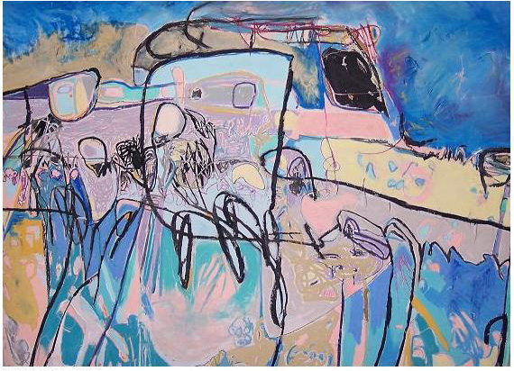
Name: Susan Harmon
Title: Coda: The Final Phrase of a Symphony
Media: Mixed media on paper
Size: 80”x55”
Date: 2006

The next drawing I discuss is Words Floating and Falling, (figure.2, pg. 22). This drawing is inspired by a poem written by Eric Nelson.

Kisses were in the air, and rain,
all around us wetness, slapping
of whispers, of bad tread, our lips
coming apart. Your fingerprints
on the glass, tapping, the fountain
in the park spouting, the water rising
as if falling, weren't possible even
as the rain fell in whispers, small drops
with words inside, rain on our tongues
with stay inside, with how. In the fountain
the words floated in circles, wishes that
wouldn't sink or come true.Eric Nelson

This picture is filled with organic and circular shapes that vary in size. The spatial relationships between forms are important to give the feeling of “the words floated all around” and “rain which fell in whispers”. Rain may fall quickly and hard where whispers are calm and soft so quiet colors are used in a smooth and flat manner to express these ideas. There are agitated scratch marks coupled with blurring and smearing marks to create an emotional mood of how rain and kisses may feel. The color palette has a wide range of colors including greens, blues, pinks, purples and yellows to express the different kinds of words falling; the different kinds of rain falling, and the different kinds of dreams we dare to dream. None of the circular shapes have been grounded as to express “wishes that wouldn't sink or come true.” This poem is the beginning of the connecting themes of hope which run throughout most of these inspirational writings. Some bright colors are used to represent the hope that these wishes due come true. Weightless or thin marks try to reach out to the circular or (word) shapes to try to connect them to each other. The strong green color used in the upper right hand corner expresses the feeling of how the possibility of a storm (metaphysical) coming may feel. At first glance this picture has a pleasant overtone with directed and controlled circular marks throughout however some agitated dark pink lines and smears remind the viewer that not all words or wishes are good. This picture does not illustrate this poem. Instead, it emphasizes the sadness of wishes, which are shown in the shapes floating around the picture and in the end do not come true. In this poem we are teased into thinking that the possibility of dreams coming true may be a reality. The dreams may come close to becoming a reality( as shown in the shapes which fall quietly ) and give us a taste of becoming a reality (shown again in the colors used on these shapes) but in the end dreams don't either come true or die they are just out there(as shown in the shapes which are suspended) as our hopes and dreams not yet fulfilled.

.

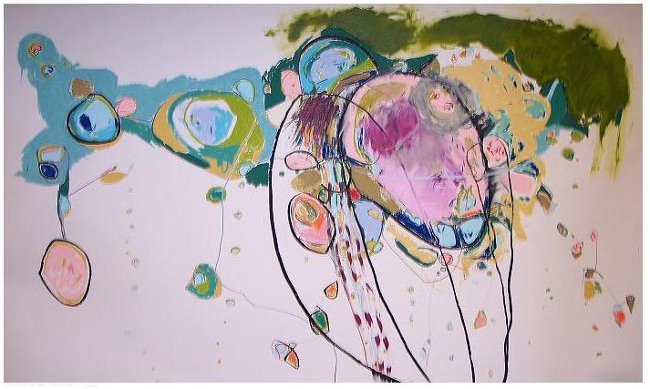
Name: Susan Harmon
Title: Words Floating and Falling
Media: Mixed on canvas
Size: 80”x55”
Date: 2006

Not only poetry, but also songs and myths intrigue me as I look for inspirational writings for me to work from. The third drawing is Dreams Spilling Over, (figure.3 pg.25), which is inspired by a Native American myth.

An Ancient Chippewa Tradition

The dream net has been made
For many generations
Where spirit dreams have played
Hung above the cradle board,
Or in the lodge up high
The dream net catches bad dreams,
While good dreams slip on by.
Bad dreams become entangled
Among the sinew thread
Good dreams slip through the center hole,
While you dream upon your bed.
This is an ancient legend,
Since dreams will never cease,
Hang this dream net above your bed,
Dream on, and be at peace.
Author unknown

The black lines of the large circle represent the safety net that holds all the bad dreams. These bad dreams are expressed by drawn, smaller and odd shaped circles that sit inside the one large circle. Good dreams come tumbling out of the large circle. Although they may bounce around for awhile, they do finally stabilize themselves on the bottom of the picture where the shapes lay side by side safely and together. The long black charcoal lines are symbolic of the thread which may entangle the good dreams, as they fall out they are caught. The soft, quiet colors (pinks, grays, sand and light violets) contrast with
the dark colors to express different types of dreams. Stormy deep blues are used to emphasize the difference between bad and good dreams. The focus of this picture is on the center of the page where there is a beginning of a rhythm of the repetitive circular forms and continues in the patterned half moon shapes. Although the forms in the center of the large circle remain still and huddled together to show they are being stopped and cannot fall out, one white shape is separated from the others and slowly begins to fall. Showing this to remind us that there may be a fine line between good and bad dreams and it may not be so easy to capture and save all the bad dreams. Marks are subtly scribbled in light flesh tones under these bad dreams emphasizing the disturbing feelings that can come from them, while one thick scratch mark surrounds the group of small circles to show they are the safe and good dreams. Grey repetitive loop marks are drawn to the side of the picture to emphasize dark dreams are brewing. The large white space is left as a void where no dreams have even begun yet. Marks made in patches of colors are smeared periodically around the entire painting giving an emotional mood to the entire surface to express the feeling that the act of dreaming can be an emotional one. Through dreaming and remembering our dreams we are made aware of our deepest fears and greatest hopes, on a conscious level. This reality can be frightening as shown with the many agitated scratch marks.

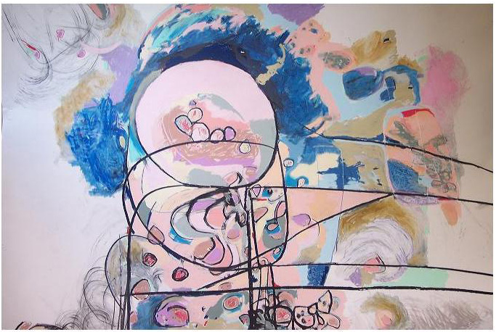
Name: Susan Harmon
Title: Dreams Spilling Over
Media: Mixed on paper
Size: 80'x55”
Date: 2006

The next drawing, Nocturnal Silence#1, (Figure 4, pg.28), is inspired by a passage from the book titled Night, by Eli Wiesel. This book is a powerful and emotional true story of a young, Jewish boy and his father imprisoned in Auschwitz, Germany during World War II. I created a series of five drawings inspired by this book which focused on minimalistic marks to express these dark feelings of the boy in the story. This art work, Nocturnal Silence#1 is directly inspired by this specific passage, from Night:
Never shall I forget that night, the first night
in camp, which has turned my life into one
long night, seven times cursed and seven times sealed.
Never shall I forget the little faces of the children,
whose bodies I saw turned into wreaths of smoke
beneath a silent blue sky. Never shall I forget those
flames which consumed my faith forever. Never shall
I forget that nocturnal silence which deprived me,
for all eternity, of the desire to live. Never shall I
forget those moments which murdered my God
and my soul and turned my dreams to dust.
Never shall I forget these things..... Eli Wiesel

The importance of this passage is in the smoke, the smoke which is a constant reminder of the death of children, mothers and fathers, sisters and brothers. The smoke which is always present. These drawings are made on a prepared ground mixture of black acrylic paint with pumice. Each paper, used for the series of drawings were covered with the pumice mixture first and let to completely dry before putting any marks upon it. Oil pastel with chalk pastel is used to make strong colored lines to represent the wires that surround the camps. The book, Night, continually describes the dense smoke that never leaves, which was a constant reminder to them, of who was dying and how. Even at night when it is the time to sleep, one could not forget that smoke. Those images stayed with me and are depicted with smudges and smear marks of pastel. Isolated and lonely different colored fragmented marks are used to represent the people, alone forever especially at night when the silence comes. The horizontal fragmented red mark at the very bottom of the paper represents the anger growing. The thicker blue-green vertical symbolizes the constant sadness as they cross each other to make a rectangle which holds the various organic circular shapes inside their prison. The rubbed wide sweep of a mark beneath the clumped circles stands for their white light of hope. There are various thicknesses of white contour lines outlining the circular shapes reminding that hope surrounds everyone if even for a very short period of time. The smaller circular reddish marks are caught in the constant smoke of death as the white rubbed marks swirl around
never to stop.

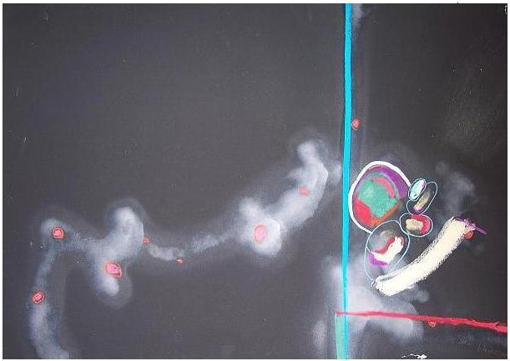
Name: Susan Harmon
Title: Nocturnal Silence
Media: Mixed on paper
Size: 22" x 30"
Date: 2006

Another powerful book, about two sisters who survived the holocaust, inspired my next set of five drawings. Rena's Promise by Heather Dune Macadam talks about Rena and her younger sister, Danka as they survive the first transport to Auschwitz and even survive the death march. Rena promises her younger sister that, if she is selected first for the gas chambers, Rena will hold her sisters hand as they both die together.

From a song sung by prisoners in the camps:

“From the distance through the iron bars
Freedom is laughing at us...
But the sun's still not shining.”
Rena Gelissen and Heather Dune Macadam

My image Freedom is Gone#1, (Figure. 5, pg. 31), is one of a series of five minimalistic drawings inspired by Rena's Promise. A mixture of brown-tan acrylic paint and pumice create a ground with a texture like sand paper which soaks up the chalk pastel producing brilliant color. The prisoners could easily look through the barbed wire which surrounded them to see the freedom that was not theirs. To express this feeling of their being teased with freedom I scratched marks, uneven and arbitrary, into the painted pumice texture, at the bottom of the picture to symbolize the barbed wire, but left a large rectangular shaped space to represent the boxed in cage which held the prisoners. This also represents a window which they could look out at the freedom, or empty space surrounding them, but could not touch it or go there physically. Intentionally I left so much empty space around the wires to show the irony of so much freedom so close yet so far away surrounding the prison. There is a dominant bold black angular mark in the center of the paper so your eyes will focus first on that strong mark, and then look up onto the two blue smear marks of paint, above them. The black mark is taken from the lines which make up a Star of David, to represent the religious belief standing strong even in this prison. The light sweet bluish color metaphorically symbolizes the taste of peaceful freedom. These marks appear intuitive and simplistic but they are nothing of the kind. In order to make the right mark which truly would express the feelings of someone who has once known freedom and may never know it again, I needed to make many sketches of barbed wire and then to pull the one mark which would stand for all the barbed wire keeping all these people prisoners.

.

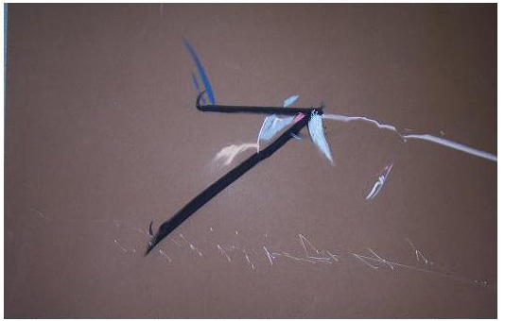
Name: Susan Harmon
Title: freedom is Gone # 1
Media: Mixed on paper
Size: 22" x 30"
Date: 2006

There are so many powerful and emotional words to draw inspiration from. Choosing which passages to use was difficult for me. This body of art was created as a remembrance to those who struggled and survived, sometimes not by choice. It is my hope that through focusing on mark-making I have created powerful and emotional images that express the strong feelings represented in these passages. Reading books about the genocide in Rwanda, the Holocaust in Germany and The Apocalypse gave me strong emotional words to paint. Hearing the poetry of William Shakespeare, Dr. Eric Nelson and Native American tribesmen gave me powerful words to feel. Listening to the music of Findlandia, Bob Dylan and Judy Garland gave me beautiful sounds to express. To make pictures with the intent to evoke emotion in the viewer based on words, sounds and feelings is my objective. To create pictures which express my deep feelings about the subjects is what is most important. I have no interest in trying to illustrate or recreate the setting of these stories or to draw the faces of the people in these books. Intentionally I do not want to be influenced by other artists who may work this way. I want to be original and remain as pure as possible in my thoughts and feelings. I feel that there may be danger in being overexposed to artists and philosophers who may have similar intentions as I do. In the writing of this thesis and in the creating of these thesis artworks I need my mind to remain as free as possible to develop my own methods and means of expression so that even if it be at a subconscious level I do not imitate someone else's ideas.

CHAPTER 2

HISTORICAL AND ARTISTIC INFLUENCES
The cave of Lascaux, a chance discovery
by two boys in France in 1940, is the most
striking we have ever had, into the enigmatic
world of the old stone age. As glaciers made
their last advance and retreat into Europe some
18,000 years ago, cavemen were painting in the
underground galleries and chambers of Lascaux.
It is now a sanctuary filled with evidence of the
human spirit that we are only beginning to discern.
Geologist, Norbert Aujoulat
Chapter Two examines the different marks made by Paleolithic man. This chapter presents various techniques, materials and reasons of Cave man to create the art on his walls and how I relate to these marks in my art. In this chapter I examine Native American petroglyphs and pictographs and the emotional marks used in their signs and symbols. Jean Michel Basquiat, Cy Twombly and Susan Rothenberg are contemporary artists who have influenced my mark-making. Specific art works of theirs is presented with comparisons of their marks to my own.
The emotion expressed in the marks on caves some 40,000 years ago is what intrigued me to study cave art. Those first marks put down by human hands were made for many reasons. Although many marks were left for obvious reasons such as tracking history, a successful hunt or battle and magical or spiritual rituals for hunting or fertility, some of those first marks were “created for pure artistic reasons”.1 There are thousands of images preserved on cave walls and many with a focus on personal expressive marks. Those images of most interest to me are the ones with deeply incised marks which seem to me to show anger or some strong emotion. The variance of line weight; with some lines thick and dark, appear to be made deliberately to express a dark feeling. These intense marks seem to contrast the beautiful, delicate and subtle lines which also appear often. Cave art with paint smears made with the palm of a hand or irregular marks which form strange shapes intrigue me. I identify with these awkward and emotive marks, all of them seem to me, conscious choices made by the hand of the artist/Paleolithic. These artists and their marks relate to my own emotive mark-making techniques as I also use these same artistic techniques. The first marks in this elegant cave painting are harsh deeply incised lines, irregular and possibly arbitrary. Small engraved and painted horses, (Figure. 6, pg. 35),which is on the wall of The Lascaux cave in France, combines detailed delicate lines used for the horse's mane, hair, eyes and feet with a very simply solid painted body. The outline of the two horses is drawn in black charcoal line. The bodies are colored with a rich chocolate brown color. The lines used are subtle and sensitive. This is a most beautiful and naturalistic depiction of the horses, the artist has captured a personal expressive quality with these renderings. The incised agitated marks overlapping the horse bodies partially cover the bodies placing focal emphasis on the faces. Dale Guthrie, author of the book entitled The Nature of Paleolithic Art, supports the conclusion that Paleolithic man made art for personal expression. He calls the maker of these images Artists, not only hunters and points out that their renderings of animals and other unidentified marks are not only precursors to the written language but depict deeper and more meaningful ideas.

“It is the code-breaker. Paleolithic artist-hunters
were keen students of natural history, they had
to be. Their art is not an obtuse symbolic
language but something very deep and very dear.”2
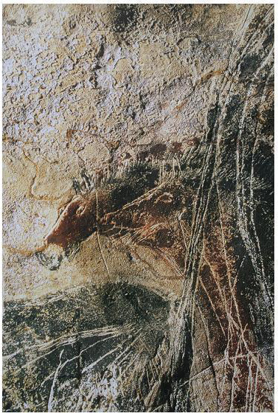
Title: Small engraved and painted horses
Lascaux Cave, Dordogne France

I made a series of ten drawings influenced by these emotional cave marks in which I directly borrow some visual components trying to make them my own. Paleolithic Sanctuary#1, (Figure 7, pg.37), is a part of this series. This drawing is on long brown wrapping paper to represent the sacred cave. Broken shapes and forms symbolize human body parts and animal parts woven together. The marks used are made in a minimalistic manner with oil paint sticks, for intense color. Pastel marks are rubbed and smeared with the palms of my hands to create an atmosphere of a sacred and holy place as a safe haven. One abstract, precursory loopy long mark connects the smallest of the human forms to the end of the cave where the safe world would end and the rest of the world would begin. The red short splattered marks are used minimally to represent some anger and physical pain which may seep into the sacred cave. The negative space is intentionally left to place important focus on these emotional marks. In this picture I wanted to stress the importance of the sacred activity within these quiet dark walls. Intuition plays a big role in the making of this picture in order to allow myself to express pure emotionality as possibly the cave artist did.

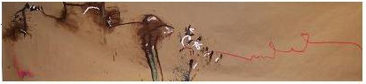
Name: Susan Harmon
Title: Paleolithic Sanctuary
Media: Mixed on brown wrapping paper
Size: 80”x30”
Date: 2006

Another example of emotional mark-making techniques that emphasize direct and immediate mark-making are those used in Large Panel of Red Dots, (Figure 8, pg. 39) comprised of numerous red forms which are similar in size, shape and color. These marks were made by a man putting the palm of his hand, covered with color, on the wall to smear the paint. The effect is an expressive and emotional one. Although most red color in the dots is intense and consistent some are more faded continue upwards to the ceiling. There are some faint finger marks visible. One could almost feel the pain expressed by these early men as they pressed their hands to these cave walls to create these marks. Interpreting the strange positioning of the red dots is difficult with some so close to each other and obviously forming the main group of dots. But why are not they all put into the main group together? When viewing the dots as one image it appears as if the whole image is of one single human hand. Was that accidental or intentional? I use similar mark-making techniques in my work as if trying to force the viewer to look beyond the obvious.

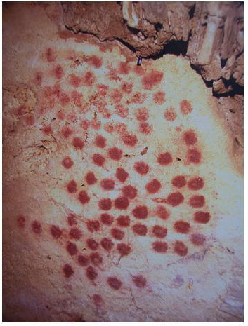
Title: Large Panel of Red Dots
Entrance to the Alcove of yellow Horses,
Chauvet Cave, Rhone Valley, France

Influenced by these emotional mark-making techniques of simple and direct mark-making, I made an image called Cave Marks #1, (Figure 9, pg. 41). This image began with a coat of acrylic paint of deep rich chocolate brown painted in a thick layer on heavy weight arches watercolor paper as a background and to represent the sacred cave. I drew marks in the wet paint with my fingernail creating agitated scratches to invoke an aggressive mood. Torn bits of blue handmade paper are centered in a scratched geometric shape to represent body parts resting in a safe place. Streaked marks of paint are barely visible in the background and in close proximity to the dense brown paint. The faded color red peeks through the openings nearing the body parts. Danger is close but the two forms are protected. The scratched circular marks outlining the two dominant forms are to connect them together. The two forms rest off balance on cut geometric pieces of raw canvas which is acting as a stabilizing force for the forms, to provide a secure place for them to stand, safe from harm. The scraped finger marks in the thick brown acrylic paint which surround the forms (were made to imitate the incised lines of the cave paintings) as if gently lulling them to move out of their safe resting place.

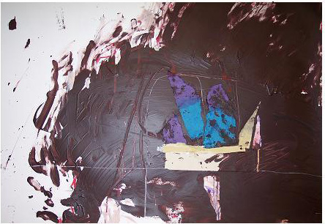
Name: Susan Harmon
Title: Cave Marks
Media: Mixed on paper
Size: 18”x24”
Date: 2006

Other historical influences important to me are based on Native American myths, stories and symbols. Petroglyphs and pictographs are the two kinds of rock art created by Native Americans and others around the world. Petroglyphs are carved images into a dark surface (patina or rock varnish) and pictographs are painted images on the rock surface with natural pigments. Making the petroglyph was a very difficult and time consuming act but had a high degree of permanency. This idea of dedicating a large amount of precious time to making art is evidence of its importance to Native American Artists. The colors used to create Pictographs' were derived from the earth; white or yellow clays, charcoal, iron oxides and copper and are similar to the color palette used to create these images of mine. “American Indians had no word for art since creativity was part of the daily life...It is clear that the ancient symbols on rocks can be complex and powerful metaphors-much more than adornment.”3 John Dewey also stressed that art works are made up of every day life experiences and the cultural life of its community has a great influence to it. Among the many reasons for creating petroglyphs and pictographs were using them to mark their territory, trails, and fresh water springs. Images of religious shamans, for prayers or visions, were typically expressed as very simplistic stick figures. Pictures of successful hunts and battles were frequently painted. This supports Dewey beliefs that art is made up of these shared social experiences. These different types of images were placed in remote and sacred areas removed from Society, which left these important marks hidden and secret. Often these images were made to communicate myths and stories from one generation to the next. But they all share the common thread of personal expressive mark-making.
My interest in the use of natural colors (used in these pictographs) and the ideas of the importance of every day life experiences as sacred visual images, is shown in my drawing, Death Rattle, (Figure 10, pg. 46). It is drawn with chalk pastel on blue textured paper. This picture was made with marks of smearing and blurry smudges that blend ochres, whites and charcoal to create a feeling of mystery. The last breath taken before one dies is a mystery in that the person cannot talk about what he/she is going through. These expressive marks are used to create a deliberate feeling of sadness. This picture represents the very last phase of death, when one is laying on his/her bed, not in a conscious state of mind. Death is nearing and the breath turns raspy, barely audible as the last breaths of life. The white short blurry marks are for the light at the end. The blues are for the coldness. The thin long marks which cut through the middle of the page are taken from the lines of the barbed wire to represent being held prisoner with no control of life. Life is stolen. This very personal picture expresses my private ideas about death and dying which relates directly to my father's passing. Although this piece may fit into John Dewey's theory that art must be a result of everyday life experiences it also reflects Tolstoy's theory that art needs to be expression of feelings that are actually felt. This picture is really about how I felt as my father was dying not about how he felt as he was taking his last breaths.

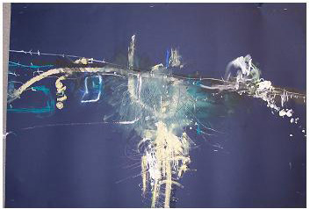
Name: Susan Harmon
Title: Death Rattle
Size: 22" x 30"
Media: Chalk pastel/blue paper
Date: 2006

Storied Stone, a book by Linea Sundstrom, describes the art of trance as a state of being used by Native Americans. These trance states are described visually in some rock everyday experience.”4 It is thought that the creation of these abstract marks, found in many caves, may have been made to help the artists to remember how it actually felt when they were in this trance state of mind. This is often the way I feel when making many of my marks. A series of very small images, 10”x10” paintings on masonite board, made for my thesis exhibition emphasizes the idea of using a trance state through expressive and minimalistic marks. Two Souls, (Figure.11, pg. 48), is the first of ten images, in this descriptive series, that focuses on simple, direct and immediate mark-making. Oil paint sticks are used to make a thick, uneven black mark around the central two forms. The forms are created by attaching torn brown paper bags pressed close to each other. In the wet paint I scraped and clawed with my nails, leaving incised looking marks to emphasize intense emotion. Other marks used are similar to calligraphic sweeping and smooth lines put down quickly in order to create a feeling of confidence. A Mixed dull green color is smeared around the central segregated green shape to symbolize darkening emotion. Imperfections were welcome in this image in order to achieve a spontaneous effect. There is one oval shape floating in a sea of dark color as if it is being pulled into it. The importance of these marks is to place emphasis on the two souls together, forever and the one separated soul will never belong with them. The significance of the scribble words (which are partially wiped out) is that they are almost wiped out, like the separated form which eventually will be totally wiped out and only the twp souls will remain,together and as one.
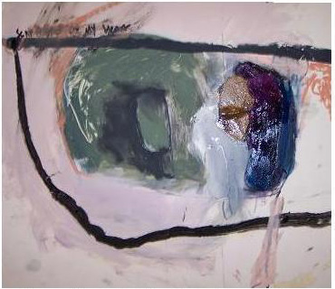
Name: Susan Harmon
Title: Two Souls
Media: mixed/ masonite board
Size: 10" x 10"
Date: 2007

At this time, I begin to solidify the feeling that mark-making should utilize techniques that maintain high standards while remaining true to personal expression. Although the quality of my lines remain very important to my art, mark- making, in a very quick manner, to achieve more intense emotional marks with less self consciousness becomes a more important idea to me. Spontaneity and intuition become significant important elements to making my art, yet the formal elements of color and composition are still important. I begin to search for more honest ways to make my marks. Discovering the art of Jean Michel Basquiat and his raw emotional marks gave me those answers.

“I could not stop looking at it.
Ultimately,
I was overcome by a sense that
I was standing in front of
something emotionally genuine-
but I understood little else about it.”
Marc Mayer, Editor of Basquiat
Jean-Michel Basquiat was one of the most prolific artists of the twentieth century. I also work very quickly and produce large quantities of art. He evolved very quickly, at a young age, as an artist creating unique pictures about his ethnic and cultural background. He interests me with his raw and primitive emotional marks. Often using stick figures with exaggerated facial features that placed emphasis on enlarging teeth and eyes, many of his figures had oversimplified body parts, especially distorted hands and elongated hair strands. I have developed new forms by oversimplifying body parts and reinventing those forms to make them my own. Hip Hop music was a large influence on him as music is a large part in my art process. Almost always words, letters or numbers show up in his works to emphasize an important political message. Many of his paintings are thought to be self-portraits, as one of Basquiat's many black mask pictures, In This Case (Figure 12, pg. 51), seems symbolic as a self-portrait. It has similarities to other self-portraits of his, with gross distortions of the facial features especially the large Egyptian, almond shaped eye. There are repetitive marks outlining the eye placing focus on the eye. Patterned small short marks underline the eye. The distorted angular nose also has emotonal slash marks around it. The enlarged lips with over simplified teeth shapes are emphasized with black marks outlining each one. The intense use of irregular black lines connect the facial features to complete the face. I use black lines often to emphasize, outline forms and connect shapes. This profile resembles an African mask with an angry feel to it. The intense red color for the background supports the angry feeling of this picture. Strange geometric marks, varying in size, float around the dominant profile. Patches of white paint in odd shapes float in the background. While I utilize some similar formal elements in my work, the most important similarity is in the emphasis we both place on expression of personal emotional feeling and our need for direct immediate intuitive process in order to achieve this.

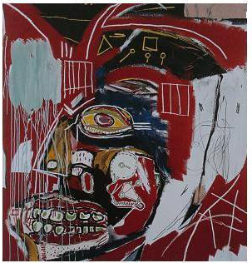
Name: Jean-Michel Basquiat
Title: In This Case
Size: 77”x74”
Media: acrylic and oil paintstick/canvas Date: 1983
After reading Basquiat, edited by Marc Mayer, I learned new information about Basquiat. Basquiat used many symbols, contour outline lines and words in his compositions. Mark-making was always a most important element in his work with scribbling and agitated bold color marks. Intense emotional subject matter is a constant element in his work. Like Basquiat's images mine have evolved to enhance their emotional meaning through utilization of torn materials, oversimplified primitive forms, distorted darkened outlines and bolder color statements. Crude symbols begin to appear in my work in order to stress emotional content. My first attempt at incorporating 3-dimensional materials to make an image is shown in Dead Silence (Figure.13, pg. 53), a picture about a newspaper article I read of Palestinian women who were protecting male soldiers through acting as human shields. This image integrates three dimensional materials with paint and pastel to express emotion. Torn pink paper, varying in size and shape, printed fabric, old discarded drawings of mine, and wire were the 3-dimensional materials used in this painting. Oil and acrylic paint, chalk pastel and charcoal were used to create a tense atmosphere surrounding these odd forms. The shapes are torn apart and try to fit together as a complete whole metaphorically symbolizing these women who try to represent one unified protective shield. Paint drips, fingernail scratches, and color smears are used as expressive tools.

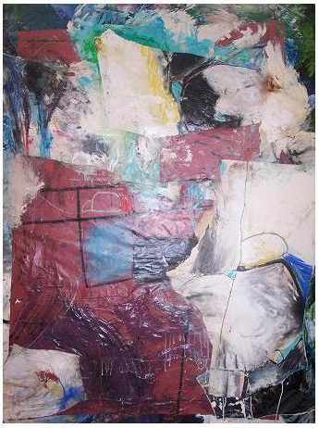
Name: Susan Harmon
Title: Dead Silence
Media: Mixed on canvas
Size: 22”x30”
Date: 2007

To make my marks more sophisticated and controlled, more intimate yet bold was the next goal of mine. Richard Leeman, author of the book, Cy Twombly, gives new insight into Cy Twombly as an artist who places emphasis on expressive mark-making. Twombly has greatly influenced the body of art I created for this Thesis Exhibition. His marks are often made through direct physical contact to the canvas, working as if he attacks the canvas with his scratched and agitated marks versus using a tool or paintbrush to make his marks. Many of his marks create repetitive lines made with overlapping aggressive marks. His shapes and symbols may seem crude and primitive but they are not. The thick, rich quality of his paint handling is often applied using his fingertips in an assertive way. Often Twombly will blur edges, wash out marks and then bring them back again and again, sometimes leaving a faint ghost image. Leeman points out,

“In October 1967, the Leo Castelli Gallery offered
the New York public something other than what
they were accustomed to from Twombly. No
literary references, no allusive titles, no figures:
nothing but very large, gray panels.”5

Ironically these paintings were labeled Blackboards, possibly due to their resemblance to school blackboards with white chalk marks. These marks were likened to children's' handwriting, graffiti and the Palmer Method of handwriting taught to school age children. According to Leeman, this demonstrates the ignorance of the non-art world that labeled these loopy and scribbling repetitive marks erroneously. The author also points out that it was believed Twombly was saying he was punished and by rewriting these similar marks over and over again he was saying he was sorry.
Twombly's image, Untitled, (Figure.14, pg. 56), is a detail of one of these Blackboard pieces that uses repetitive lines similar in size and intensity, with small variations within each line. The constant movement of the lines, with their sweeping and loopy marks, presents for me an exciting rhythmic pattern. The overlapping lines seem to bounce around and across the flat picture plane. These expressive marks seem honest, raw and unedited like some of my images. There seems to be no central focus rather the entire picture has equal emphasis. Although the picture appears flat the loopy lines pull you in and out with varying degrees of values and size to them. This is a technique I use with marks of similar shape but different intensities and sizes to them to produce an effect of weaving the viewer in and out of the picture. I admire the personal quality of these lines which seem to take on a life of their own.

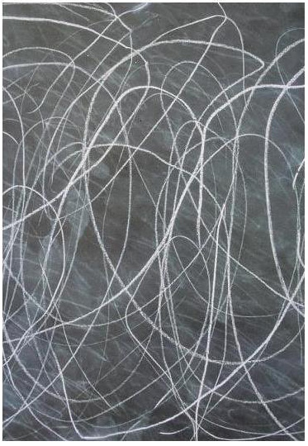
Name: Cy Twombly
Title: Untitled
Media: oil pastel, industrial paint/paper, size: 27”x39”
Date: 1970
After studying Twombly’s’ work I decided to eliminate simplified symbolic
figurative shapes from my work through attempting to make my marks more sophisticated, my lines more complicated, and my colors less mixed and more pure. With this new focus on technique a new series was born. Untitled#1(Figure.15, pg. 58), is a drawing I created on raw canvas (no gessoed surface). I intentionally made these marks to seem meaningless and unfinished to create an atmosphere of unrest. I consciously tried to activate the negative space by drawing similar repetitive marks into the empty space. Broken and erased lines in the background, resemble Twombly’s’ canvases. Large and loopy marks weave in and out between the background and foreground. Isolated areas of the painting surface is covered with layers of built up paint and then scratched out. Agitated, scribbled marks are covered with smears of black acrylic paint and overlapping black charcoal marks. Pieces of raw canvas are attached and aggressive patches of their lines are used to give a fragmented look. I decided to try to limit my editing in order to produce a more honest picture. This was a success in terms of creating an image which is more intuitive and less cluttered with unnecessary symbols and marks.
To allow spontaneity freed my subconscious of established forms and marks thus producing a unique and personal emotional statement.

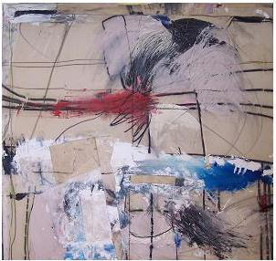
Name: Susan Harmon
Title: Untitled#1
Media: Mixed/ canvas
Size: 30”x40”
Date: 2007

At this point in my development eliminating all 3-dimensional and attached material became important to create the next series of art in this MFA Thesis Exhibition. I had come full circle with my search for new ways to make expressive marks. I now felt that having gone through so many different phases in my artistic process where I used any material I found appropriate, and utilized many experimental techniques, it was now time to develop and strengthen my expressive use of the paint medium. Susan Rothenberg's images were just the influence I needed to help me complete this MFA Thesis Exhibition. Susan Rothenberg’s pictures are very forceful and often have a fragmented feel. Her rigorous paint marks often appear both aggressive and expressive. Sandy Brooke, author of the book, Drawing as Expression says “For Susan Rothenberg, the significance is the very finding of a new formal device, the thickened line, which she describes as neither line nor shape but rather a 'band'.”6 She explored new techniques, unafraid to experiment as long as she could remain true to her feelings and be expressive with how her paint describes her images. I recognize those qualities and try to incorporate those ideas into my mark-making techniques. Her canvases have recognizable animal and human body parts, although usually abstracted and altered. Often these distorted images are painted with strange and with frenzied marks. Rothenberg seems to make dreamlike, floating images, often with no ground. Her painted surfaces are rich with exotic and sensual marks which capture an intense and raw untamed spirit, one that helps me see how to express. My images use large and continual sweeping, paint marks often combined with smearing, rubbing and a constant blending of materials to attain a desired effect that can also be found in Rothenberg’s' work. An emotional moodiness prevails in most of her work. Those thick and jumpy paint marks are full of energy and emotion that I can learn from and use. The Monk, (Figure.16, pg. 61), by Susan Rothenberg is covered with agitated and aggressive paint marks creating an extremely expressive and emotional image due to how she handles her paint. Joan Simon, author of the book, Susan Rothenberg says:

Susan Rothenberg has had the audacity to make paintings that are inscrutably private as they are publicly accessible, as formal as they are magically expressive, as figurative as they are abstract....that has merged painterly issues with autobiographical concerns...her own intuitive search for image, content and surface handling has matched her
consistent desires to catch a moment, the moment to exemplify an emotion. Joan Simon

This painting demonstrates extreme movement in the agitated marks covering the background while the figure in the foreground seems calmer. There is no need for individual facial features with such emotional marks to define the face. The loose but sensitive gestural marks for the arms and hands are expressive. A dark moodiness prevails in this image with a sense of mystery. But it is the emotion expressed in the paint strokes which grabs my attention.

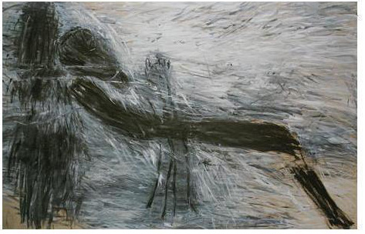
Name: Susan Rothenberg
Title: The Monk
Date: 1983 Size: 5'9”x8'9” Media: oil paint/canvas

After studying the work of Susan Rothenberg I began work on the final series in this MFA Thesis Exhibition consisting of three large paintings on raw and ungessoed canvas. Findlandia #1, (Figure 17 pg. 63), is the epitome of what I have been trying to express. Restricting myself to acrylic, oil paint and chalk pastel to create an emotional painting was the problem before me. By not focusing consciously on content, my mind was freed to focus on pure abstraction of form and color. My emotional marks remained as these paintings flowed easily and with passion. Instead of painting the written word I now wanted to paint the sounds. I allowed myself to lay down paint with unusual instruments such as cooking spatulas, brooms, and sticks. While the black marks still remained, they are less contrived and planned. The short repetitive paint marks in the center of this image are completely spontaneous. I allowed paint to drip without controlling it. While this may appear to have some human facial features in the center of the main image, it was not intentional. I wanted the marks to interact with each other as if dancing together. The symphony is complex with engaging beautiful sounds like a fountain of colors. This is a successful image of emotional mark-making through spontaneous and intuitive procedure.
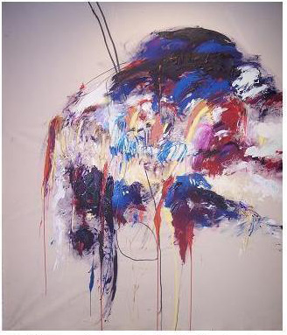
Name: Susan Harmon
Title: Finlandia # 1
Media: oil, acrylic, pastel/canvas
Size: 6'x4'
Date: 2007

Sandy Brooke, author of the book, Drawing as Expression quotes Phillip Guston,

I wanted to make drawing more like painting,
without contour. These are drawings with
masses from accumulated strokes. His
marks were directed, not accidentally didn't
just toss a mark upon the paper-rather he
had a purpose and a direction in mind, thus
the articulation of the painter's mark .
Phillip Guston

This chapter places importance on historical research through producing supporting evidence which shows direct correlation between Paleolithic, Native American, and Contemporary artist’s influences on my thesis art. The marks used by an expressionistic artist, whether made by early Paleolithic man or by a contemporary artist, have the same purpose. That is to use the marks to express one's most inner personal feelings. Once those marks become a physical reality - when they put down on that canvas for the world to see - the emotional potential has truly become a reality. Scribbling, smearing, scratching surfaces to express oneself, often in a frenzied way, can be part of a painful yet a necessary process. If a painter is courageous enough to allow himself to reach deep in his soul, to find his true voice, these intimate marks will come. This passionate process which expressionistic artists must go through, in order to leave our most honest mark upon that canvas, is rewarded when viewers are able to share the passion we have expressed. Through experimentation of materials and procedures and by allowing historical and artistic voices to influence my art I have been successful in creating a body of art which emphasizes emotional mark-making.

CHAPTER 3

ARTISTIC PROCESS AND TECHNIQUES

I think that for myself, feeling and making the image happen are essentially the same thing. Perhaps the most important thing the artist brings to the image-making act cannot be expressed in words-it's that je ne sais quoi
that hopefully produces beautiful art.
Helen Frankenthaler,

This chapter describes my artistic process and its significance. I explain the importance of passion to this process. To communicate the feeling of immersing oneself totally in physical, vigorous emotional painting and drawing and the power it holds over me is a concept explained in this chapter. Specific art works are presented to support these ideas.

My process always remains the same even though the subjects may change. To me, procedure is often more important than the final picture. My procedure begins by absorbing myself in my subject. Research comes, for me, with frenzied reading and constant note taking. The most poignant words or phrases from those notes are transcribed on the walls in my studio. The blank canvases already hang in their place as if waiting for me to touch them. Before working on the canvas, the sketches come. Whether drawn with ballpoint pen on napkins during the late night hours, or by painting with thin color on paper, I have begun to become obsessed with the art that is about to happen. My subconscious is preparing to paint.
Vincent Van Gogh said, “The only time I feel alive is when I'm painting.”
This is how I feel; sometimes I can barely make it into the studio without wanting to run as fast as possible. When I finally enter the studio I become transformed, feeling happy, anxious, and excited all at the same time.
My canvases usually begin with dark, black compressed charcoal. I try to not control my thinking while beginning a composition. This skeleton of the picture is the most important part for it is on this that the whole picture will be based. Once the drawing develops and the composition is completed I will begin to paint. This is where frenzy and fury take over, as if I cannot get the marks and color on the canvas fast enough.
Playing music in the background sets the mood for me; this is an important element in my process. The calm and peaceful marks which I may be searching for, or the agitated marks, reveal themselves more readily while music is playing: Whether it is Ozzie Osborne with his eerie screeching, dark intense voice, or Findlandia with its pure and beautiful symphony, or silence. More often than not, once I begin working I am so absorbed by my painting that I don't hear anything at all. After the composition is drawn and the first layer of paint is applied (which usually includes much mixing of colors) it is time to sit and contemplate the image; time to decide where to put lines, forms, or a specific color. Color is applied in thin layers, layer upon thin layer. Other times I will apply thick paint and use my fingers to smear and rub the surface of the canvas or paper. Once lines are drawn, scratching the surface begins, and the process of taking out and putting in shapes, colors and lines continues. Handmade papers or torn up drawings and other discarded pieces are sometimes applied. In order to evaluate the development of the image the paper or canvas is turned upside down, taken off the wall, hung alone on the wall or hung in a different spot. I may be seen standing on stools or sitting on the floor as I work on my pieces in order to change my viewing horizon. Often I will be found standing far back in the hallway to look at these pictures. Sometimes I have even been known to put my stretched canvases in my driveway at home, in order to drive up the street, just to look at these pictures from a different perspective.
Daily I take digital photographs of these images so I can look at them on the computer to help me figure out the editing process. Sometimes my painted canvases and the papers used for drawings are torn apart and put back together. Sometimes they remain whole. That the most difficult and time-consuming part of this process is completing the almost finished artwork cannot be stressed enough. As the artist, I am really the only person who can truly say when the painting is fully realized.
There is a group of artists known as Outsider or Folk Artists who emphasize emotional mark-making in their art, often using bold colors with figures that are simplified or distorted. These Outsider Artists have influenced my own emotional marks and use of color. Their emotional subject matter is similar to my choices. Although uneducated and untrained it is the power in that which may give them the ability to not inhibit themselves to express personal emotion without the restraint I may subconsciously place on myself. I admire this quality in that it is extremely difficult for me master.

A few people become professional makers of images or spectacle,
that is artists in the modern western sense. But there is also a rich
and varied group of creators who do not it into the official category
of the professional artist, however it is defined. At their best, they are
the creative pattern makers par excellence, often producing interesting
and powerful bodies of work that find their way, through various means,
into the public view. Here their artistic production takes on a life that
distances it-often emphatically separating it-from the producer. This is
the domain of outsider Art. Abraham Davidson, author of The Story of American Painting

Their raw spontaneous and emotional marks involve me deeply in their pictures. These pictures are strong and powerful. Outsider Artists are a group of people who seem unafraid to experiment with materials and techniques. Expressive distortions of forms, scribbles, and intricate detail describe many images from this group. Their use of primitive marks with no self-consciousness can produce a powerful emotional statement. These images often look child-like and simple but they are anything but that with sometimes complicated compositions arising out of detailed patterns. The CoBrA artist Pierre Alechinsky (b.1927) said, “It takes years to find the child-like inside oneself....” CoBrA stands for Copenhagen, Brussels and Amsterdam which were the homes of the initial founders of this art group who stressed nonconformity and spontaneity. It is this fresh and honest attitude of Outsider artists and CoBrA artists and which attract me to them. My art focuses on the importance of this creative process in which the artist must trust himself and prepare his subconscious for painting. Outsider Art, (Figure 18, pg. 69), is on masonite board, and is an image by Outsider Artist, Mikey Welsh. Color is a very important mode of expression for him. He distorts the human form through oversimplification of facial features. The enlarged mouth and eyes are almost grotesque. Geometric patterns are repeated in the teeth and fingers with dark uneven marks outlining the forms. His aggressive marks on the hair and arms are similar to the aggressive marks in my pictures. His use of outlining forms to place emphasis on them and use of emotional color and expressive marks compare easily to my own. What most impresses me about his art are the emotional faces. The odd angles of his faces pressed in angst against the angular fingers cause a feeling of anxiety. Although an untrained artist he achieves the success of creating an image with immense power to affect the viewer.

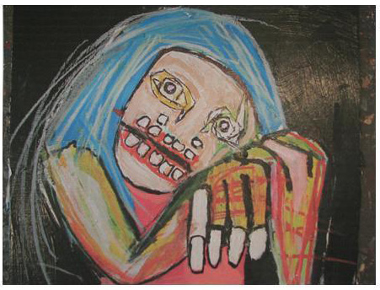
Name: Mikey Welsch
Title: Outsider Art
Date: 2002
Media: mixed/masonite board

I created a series of ten canvases involving similar mark-making techniques as Outsider artist, Mikey Welsh that also stress distortion of body parts and use some geometric patterns on torn body parts. Using torn brown grocery bags to create these forms and combining thick layers of paint with other objects (wire, staples and string) produced powerful emotional images.
Lives Stolen, (Figure. 19, pg. 71), is painted with the intent, to express emotional content through the use of primitive forms, intense marks, and thick application of paint. Color is used here to give an impression of moodiness and darkness through smearing, smudging and pushing acrylic paint, while building the image layer upon layer. The forms used represent the body parts of women who were institutionalized in Germany in early 1940s. Torn colored handmade papers along with torn brown grocery bags were attached to the canvas, torn off and then reattached until the spatial arrangements between the forms had the desired proximity. This painting began as one very long raw canvas on the wall.
After months of clawing, scratching and molding these shapes: Tearing, cutting and ripping the parts off, only to put them back, moving pieces like a puzzle which needed to fit together in an exact way, finally this picture was completed. Jean Dubuffet said, “A painter must be honest! No veils! No ruses! Everything has to be naked; presented at its worst.” I agree with this theory and try to implant it in my work. By using direct touch of my hand to the canvas or passionately tearing the materials to attach them my hope is that by osmosis my deep feelings will somehow transfer to these canvases.
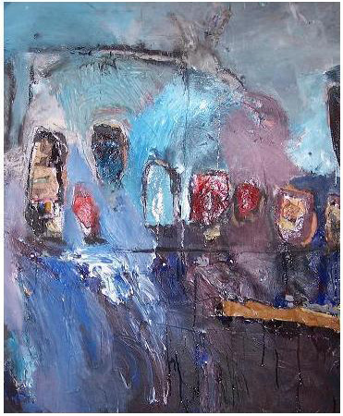
Name: Susan Harmon
Title: Lives Stolen
Media: Mixed/canvas
Size: 22" x 30"
Date: 2007

Another picture from this series, Ladies Lost, (Figure 20, pg. 73) was begun as the second part of a diptych. This picture began with a simple composition of three strange and organic forms used to represent figurative body parts. They began from torn brown grocery bags and were covered with layers of acrylic paint. The background consists of scratched fingernail marks over built up smeared paint. The aim of these marks was to give a sad, melancholic feeling to the overall picture. Again the direct approach of using my personal physical touch combined with vigorous paint application and the addition of torn paper forms to give this picture a sense of an immediate and spontaneous overall atmosphere. Many of the marks and added raw canvas strips were painstakingly planned out beforehand in a sketch for this painting only to be abandoned as I let this painting guide me.

“The image is additive; it is executed with such vigor and directness that the many notations-shimmering white and gray brush strokes-at first seem to be just a record of the act of painting. But the immediacy is only a mask. The artist has a disciplined sense of form”.
Paul Brach (on Joan Mitchell)

My motivation to use these experimental techniques: Adding torn papers, applying paint with non traditional methods, leaving entire areas of a picture empty, combining variance of line on raw canvas and allowing my subconscious to take over, all of these unorthodox procedures were important to my artistic development. Without this exploration into new methods and materials there would not have been produced a powerful emotional body of art. In order to create these intensely personal images, research of past and contemporary expressive artists was necessary. The significance of finding new ways to interpret and express my feelings towards these inspirational writings was crucial to the final outcome. Each drawing and painting in my MFA Thesis Exhibition has its own character, tone and aspect to it, albeit separate from each other, there is a strong connection between them. The process one goes through to prepare for making those intense emotional marks is so important. The rituals of making sketches, listening to music, clearing ones mind, is so necessary, to be able to actually free your mind of every day clutter and nonessentials so that the artist can find those true feelings and then try to express them through his direct marks.

CONCLUSION

The Abstract Expressionists and the critics who defended them against the charge that these quick, spontaneous paintings were no more than the mere doodling or mere decoration, insisted that the successful Abstract Expressionist painting had content, and they pointed out the danger and drama involved in the painter's rescuing the welter of strokes, drippings, and splatters from the edge of chaos. Attributing content to these paintings did not mean that the viewer could or should find recognizable images within them. Rather, it meant that inevitably he would find in the arrangement of the nonobjective forms, references to or reminders of events or feelings or experiences in his own life. That such references are not willed by the painter but come out of their own accord does not detract from their importance. Abraham Davidson

My thesis proposal to create a body of art inspired by poetry and/or writings, while emphasizing mark-making as the vehicle for expression was presented with supported evidence. The process of creating successful images for my MFA Thesis Exhibition was a positive emotional and intellectual stimulating experience. To read important stories about two sisters and their journey to survive the Holocaust, a young girl and her life of separation from her family at six years old, with the diagnosis of leprosy in 1890 Hawaii, father and son who walk across the country during the Apocalypse, and to translate those feelings of mine towards these stories, to visual marks, was a passionate one.
My research of Paleolithic Cave Art revealed insight into those first marks made by man; their meaning and techniques. Study of Native American symbols and the process of self meditation to reach their subconscious in order to create abstract marks, was of great importance to my own process during this research. Outsider art with its primitive and direct spontaneous mark- making procedures influenced my art by allowing me to work in similar ways. Susan Rothenberg with her aggressive paint handling, Cy Twombly's sophisticated lines, and Basquiat's brilliant color marks and extreme, and exaggerated facial features, changed my own mark- making through exposure to these ideas.
Jackson Pollock talked of literally being in the painting. I, too, obsessively tried to put myself, physically and mentally, in my paintings. The process of preparing my subconscious for mark-making by quieting my mind and trusting myself so that I could feel free to make these bold emotional marks was a difficult process for me to accept. As I scratched and clawed at the surfaces of these canvases to try to achieve emotional images, I felt myself slowly accepting and gaining the self confidence needed to succeed. As I smeared and smudged paint marks with my hands and as I drew bold lines on these surfaces; rubbing marks in and out, I slowly became more comfortable with this new confidence in myself to produce successful emotionally strong marks. Through constant experimentation with materials and art processes I had gained many more tools and methods to help me achieve these expressive paintings. By dripping paint over torn old drawings and canvases, adding layer over layer, I tried to create canvases rich in surface, texture and expressing human spirit.
Without the inspirational writings there would be no intense personal marks for me to make. Reading and listening to these journeys of survival empowered me to make these marks and create these canvases. I succeeded to make powerful images about people whose lives I admired and whose souls I had discovered. My search for poems and articles about people whose lives, as they once knew them, had ended, without their control, produced a new understanding and insight for me as an artist. To tap into my personal feelings and identify with these people an then to have the ability to express visually these raw and honest feelings is an accomplishment for me.
Through examination of other artists before me who have creatively expressed themselves and who have allowed deep personal feelings to be outwardly and openly exposed, is of great influence and importance to my future growth and development as an artist. I have discovered similar concepts which connect this body of art while realizing that the death of my father triggered my initial interest in people whose lives have been stolen from them. Although these persons gave up their bodies to become slaves their minds stood strong. I believe I have accomplished to create a strong body of art which stresses mark making as a means of expression inspired by personal writings.

ENDNOTES

1. Jean Clottes, Chauvet Cave,(Salt Lake City, Utah: The University of Utah
Press.2003), p.94.
2. Dale Guthrie, The Nature of Paleolithic Art, (Chicago and London: The University of Chicago Press, 2005), p.144.
3. Jean Clottes, Chauvet Cave, (Salt lake City, Utah; the University of Utah Press, 2003), p.84.
4. Linea Sundstrom, Storied Stone, (Norman, Oklahoma: University of Oklahoma Press, 2004), p. 90.
5. Marc Mayer, Basquiat, (London, New York, New York: Merrill Publisher,
Inc., 2005), p.35.
6. Richard Leeman, Cy Twombly, A Monograph, (Paris, France: Editions Flammarion, 1994), p.179
7 Sandy Brooke, Drawing as Experience, (Upper Saddle River, New Jersey: Pearson Education, Inc., 2007), p.11.

BIBLIOGRAPHY

Art Quotes. net, Paul Cezanne, http://www.artquotes.net/master/cezanne-quotes.htm.

Art Quotes.net, Vincent VanGogh,http://www.artquotes.net/master/vangogh-quotes.htm.

Aujoulat, Norbert. Lascaux. Movement, Space, and Time. New York, new York: Harry N. Abrams, Inc., 2005.

Brooke, Sandy. Drawing as Expression. Upper Saddle River, New Jersey: Pearson Education, Inc., 2007.

Clottes, Jean. Chauvet Cave: The Art Of Earliest Times. Salt Lake City, Utah: The university of Utah Press, 2003.

Davidson, Abraham. The Story of American Painting. New York, New York: Harry Abrams, Inc., Publishers.1994.

Duncan, James. The Petroglyphs and Pictographs of Missouri. Tuscaloosa and London: The University of Alabama Press, 2000.

Fitzgerald, Michael. The Spirit of Indian Women. Bloomington, Indiana: World Wisdom, Inc., 2005.

Guthrie, Dale. The Nature of Paleolithic Art. Chicago and London: The University of Chicago press. 2005.

Haskell Institute. Myths, Legends, Superstitions of North American Indian Tribes, Cherokee, NC: Cherokee Publications. 1995.

Heller, Nancy. Women Artists, New York, New York: Abbeville Press Publishers. 1987.

Hoban, Phoebe. Basquiat. New York, New York: Penguin Books. 1999.

Ilibagiza, Immaculee. Left To Tell. Carlsbad, California. Hay House, Inc. 2006.

Lagnado, Lucette. Children of The Flames. New York, new York: William Morrow and Company, Inc. 1991.

Leeman, Richard. Cy Twombly, A Monograph. Paris, France. Editions Flammarion, 1994.

Macadam, Heather. Rena's Promise. Boston, Ma: Beacon Press, 1995.

McCarthy, Cormac. The Road. New York, New York: Alfred a. Knopf, 2006.

Mayer, Marc. Basquiat. London, New York: Merrell Publisher, Inc., 2005.

Miller, Christopher. Joan Mitchell, New York, New York: Robert Miller Gallery, 1998.

Native Dream Catcher, Http://www.native-language.org/dreamcatcher.htm.

Nelson, Dr. Eric, Kisses, http://www.poetrymagazine.org/magazine/0601/poem.htm.

Paschen, Elise. Poetry Speaks, Naperville, Illinois: Sourcebooks, Inc. 2001.

Rhodes, Colin. Outsider Art. New York, New York: Thames & Hudson World of Art, 1998.

Roethke, Theodore. Words for the Wind. Bloomington, Indiana: Indiana University Press, 1965.

Rothko, Mark. The Artist's Reality: Philosophies of Art. New Haven and London: Yale University Press, 2004.

Shakespeare, William. Hamlet, http://www.william-shakespear.info/act1-script-text-hamlet.htm.

Simon, Joan. Susan Rothenberg. New York, New York: Harry N. Abrams, Inc., 1991.

Slifer, Dennis. Signs of Life, Santa Fe, New Mexico: Ancient City Press, 1998.

Sundstrom, Linea. Storied Stone. Norman, Oklahoma: University of Oklahoma Press, 2004.

Wiesel, Eli. Night, New York, New York: Hill and Wang, 1972.

The Williams College. Helen Frankenthaler. New York, New York: Harper & Row, Publishers, 1980.

