Primary Color & Line Art Lesson For kindergarten

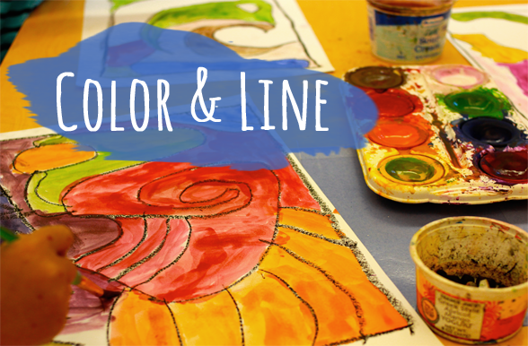
We started by jumping right into taking our line for a walk. An explanation of lines was necessary as was a discussion about Kandinsky, the artist. Looking at a line chart or drawing different types of lines on the white board is not only fun but provides the basis for this lesson.

Taking a line for a walk….

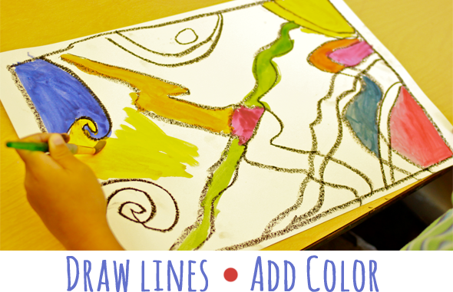

Materials:
Crayons, primary colors; red, blue, yellow
Graphite pencils
White paper
Watercolor boxes, brushes, water cans, paper towels
Art objectives:
To learn primary colors,
How to draw a line of different sizes and types
Art History Element:
Kandinsky and line, primary color and music
Directions:
- On a sheet of white paper, use graphite to draw a “frame” or border around the perimeter of the paper. This is so the kids won’t paint off the edge of the paper thus reducing the need for placemats.
- Starting at one section of the border, a horizontal line,
- then a diagonal straight line from corner to corner,
- then a vertical line,
- then a wavy line
- then an angular line like a mountain
After the lines were drawn,
- Use the three primary colors to draw the same lines in each color with crayons
- Then paint the resulting shapes with any combination of primary colors
I loved the variety of colors they chose. Each one different and unique to the artist. A great way to begin the year. Play classical music

