Scribble
From Wikipedia, the free encyclopedia
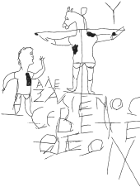
A scribble with some meaning.
A scribble is a drawing composed of random and abstract lines, generally without ever lifting the drawing device off of the paper. Adults can scribble, although generally it is as a form of abstract art, …. the picture is made by drawing quickly around the outline of object a number of times – this gives the scribbly effect. The result is a very loosely drawn, sketchy artwork.To write hastily or carelessly without regard to legibility or form.

