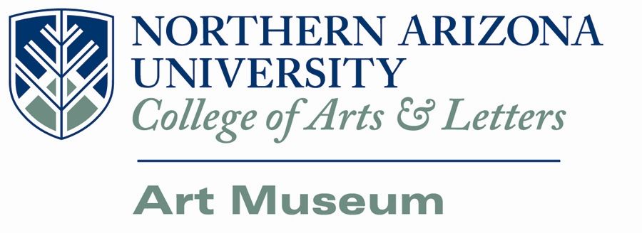

Office of the Director
July 11th, 2014

Susan Lee Harmon
2409 13th St.
Brownwood, TX 76801

Dear Susan Lee Harmon,
Congratulations! Your piece, and her parts scattered and she let them, has been chosen for the Painting in the World: Reflections on Politics, Violence, and Reconciliation at the Northern Arizona University Art Museum. Works chosen for this exhibition need to be received by the museum from August 25-29, 2014. The work must be sent prepaid; NAU Art Museum will provide return postage. All work must be presentation ready. Identification labels are to be filled out and attached to back or bottom of each art piece. Please refer to the prospectus and Display Agreement for further requirements.
We have enclosed labels and a Display Agreement form, which you will need to fill out and return with your piece when you ship it to us. Loan Agreements must be received by August 6, 2014 in order to ensure insurance coverage before the artwork arrives. Loan agreements can be sent via email to art.museum@nau.edu, by fax at 928-523-1424, or USPS PO Box 6021 Flagstaff, AZ 86011. Artwork will not be for sale during this exhibition; however values are required on the Display Agreement for insurance purposes.
Due to circumstances beyond our control, Dr. George Speer, Director of the NAU Art Museum is the sole juror for this exhibition.
If you should have any questions regarding the display terms, display agreement, or the exhibition itself, feel free to contact the museum and we will help you in any way we can.

Sincerely,

George V. Speer, PhD
Director, Northern Arizona University Art Museum
PO Box 6021
Flagstaff, AZ 86011-6021

